**Experimental Analysis of Flow Separation on Various Geometries**

Christopher R. White

Department of Mechanical Engineering

Lafayette College

Easton, PA 18042

**Abstract**

The geometry and surface detail has a great effect on the aerodynamic properties of models. The purpose of this experiment was to analyze the behavior of separation on various models utilizing the wind tunnel due to differing flow speeds and varying the angle of attack. In this study, experimental models were tested and compared to published values for coefficient of drag vs Reynolds number. The corrected coefficient of drag for spheres was _________ which corresponded to an error value of _______________. Turbulent trip and golf ball. The coefficient of drag for the airfoil was _______. When compared to the published values of cd for spheres, the corresponding error was _________ and ________. The primary source of error was _________. The goal of the experiment was to understand the effects of flow separation for both spheres and the airfoil. Then compare the measurements of the experiment to the published data in order validate the study.

**Introduction and Methods**

The geometry of an object has a significant effect on the behavior of fluid flow over the surface. Aerodynamics are an important part of the design processes for developing products for various industries, from cars, to planes, to sports equipment. An economic way of product development is by designing scale models models testing them in order to determine the optimal design before full scale.

Scale prototypes can be tested using the wind tunnel in order correlate flow behavior on scale models to a life-size model using the Reynolds number. The Reynolds number characterizes the type of fluid flow based on the model geometry and is expressed as

$Re=\frac{U_{∞}ρL}{μ}$ ⑴

where $U_{∞}$ is the flow velocity, L is the reference length, $ρ$ is the density of the fluid, and $μ$ is the viscosity coefficient with the fluid properties being approximated at the fluid temperature. The Reynolds number can be used to determine whether the flow is laminar or turbulent.

The mechanics of flow across an object can be modeled using either the Bernoulli or a model based on Newton’s laws. The Newtons Law model asserts that aerodynamic lift is the result of the angle of attack and is due to two component forces, lift and drag force as well as the formation of a boundry layer on top of the wing along with a downwash behind the wing. This results in a pressure gradient and thus causes lift as a result of Newton’s third law. The component equations for drag and lift are are expressed as

$F_{D}= F_{N}\sin\left(α\right)+ F_{A}cos⁡(α)$ ⑵

$F_{L}= F_{N}\cos\left(α\right)-F_{A}\sin\left(α\right)$ ⑶

where FN is the normal force, FA is the axial force applied, and α is the angle of attack with respect to horizontal axis. The lift and drag forces can be represented in 2D in the form of non-dimensionalized coefficients for non-spherical models as

$c_{L},c_{D}=\frac{F_{L},F_{D}}{\frac{1}{2}ρV^{2}A}$ ⑷

where FL,D is either lift or drag force, $ρ$ is the density of air at fluid temperatire, $V$ is the velocity of the air, and $A$ is the planform area of the airfoil.

Airfoils require a different calculations for coefficients of lift and drag since they have different geometry, which affects the 2D fluid flow behavior. The following equations are used to calculate 2D fluid flow for airfoils with a theoretical infinite aspect ratio as

$C_{L}= 2π\frac{AR}{AR+ \frac{2}{e_{1}}}(α-α_{0})$ ⑹

$C_{D}=C_{D_{0}}+\frac{C_{L}^{2}}{4πARe_{1} }(α-α_{0})$ ⑺

where AR is the wing aspect ratio calculated using the equation $AR=\frac{b^{2}}{S}$ where b is the wing span (wingtip to wingtip) and S is the planform area, $e_{1}$ is the Oswald efficiency number which is a correction factor for non-elliptical planform wings ( $e_{1}=1$ for elliptical wings, and $e_{1}≅0.7$ for rectangular planforms.)

In order to correlate the pressure measurements made in wind tunnels and The entire term represents the total pressure or stagnation pressure which is where the local velocity of a fluid streamline is zero. Kinetic pressure is transferred into static pressure. The rest of streamlines flow over the geometry. Molecules in contact with the geometry are not moving under the no slip assumption, and moving fluid layers result in friction between the molecules and results in the formation of a momentum boundary. As the distance between the object increases, the velocity profile reaches the velocity infinity.

The pressure and velocity effects of fluid flow in the windtunnel can be modeled using Bernoulli’s principle which accounts for the static pressure, dynamic pressure, and while ignoring the effects of the hydraulic head since there are no major differences in height. The reduced Bernoulli’s equations is expressed as

$P_{S} +\frac{1}{2}ρv^{2}=$ const ⑻

where $P_{S}$ is the static pressure, $ρ$ is the density of the fluid, $v$ is velocity. It is assumed that there is no heat transfer and no work therefore no large temperature swings and it is assumed that the fluid is incompressible.

In the current study the coefficient of drag was experimentally determined and compared with published values to access the validity of the experimental approach.

The experiments were performed by applying various flow velocities on various models to determine how geometry and surface are affects the forces as well as varying the angle of attack. It was assumed that the experiments were conducted at room temperature. Pressure was recorded using instrumentation capable of measuring perpendicular pressure to the wind tunnel interior walls. Axial and normal forces were measured using load cells mounted in the sting balance. Experimental set up displayed in figure 1.

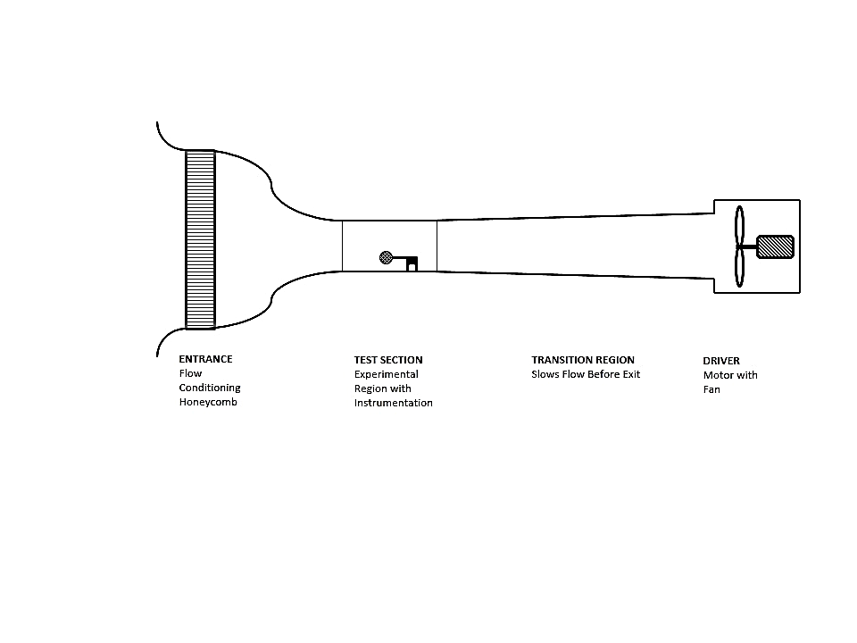

**Results and Discussion**

Three different experimental set ups were considered: (1) airflow over 3 various spheres (1.5”, 3”, 4”), (2) 4”sphere with turbulent trip and golf ball, and (3) Clark-Y airfoil model.

For the 3 spheres, angle of attack was set to zero and the readouts were tared to negate the effect of gravity on the models, axial force was measured using the load cells over various intervals thought the entire range of wind speed from (0 - 45m/s). The drag coefficient was determined using equations _____RE___ and ___Cof drag___. The coefficient of drag verses the Reynolds number was plotted and compared to the data acquired by Schlichting. The data correlates to the published results using the two different drag coefficient correlations. 1st coefficient drag model using regular coefficient of friction. The 2nd coefficient of drag correlation using special sphere correlation lead to better match with Schlichting.

A similar process was used for the 4” with turbulent trip and the golf ball analyzing the effects as laminar flow transitions to turbulences for spheres. The angle of attack remained at 0 degrees and the axial force was measured over the entire speed range of wind tunnel.

For the last experiment the airfoil was attached to the siting balance parallel with the ground. The air foil was to be tested at 40 m /s at various angles of attach ranging from -6 to + 20 degrees. Before testing began, the airfoil was attached and the angle of attack was set to zero and tared. Then starting form an angle of attack of -6 degrees, the axial and normal forces were measured in 2 degree increments to get a full spectrum of the component forces without the loads induced by flow. The experiment was then conducted at 40 m/s over the full range of angles specified at 2 degree increments while fog was emitted into the entrance of the wind tunnel and the streamline flowed over the profile of the airfoil. A laser was used to help visualize the fog streamlines by slicing the fog to get a crossectional view. The flow was video recoded. It was noted that separation began to occur at _______ and full separation occurred at ______ and when returning the airfoil to an angle of zero degrees the flow unseparated at an angle of __________.

Use the data from the experiment and the correlation (curve fit) to validate by calculating the error between the measured and published data.

The Schlichting thing is for spheres with laminar flow no tripping

The schlicting Curve fit equation for spheres was used to determine the the coeeficient of drag verses over a range of reynoldds numbers. As it is a curve fit equation, the curve was identical for all sphere sizes since the equation depends on Reynolds number.

$c_{D}=\frac{24}{Re}+ \frac{2.6\left(\frac{Re}{5.0 }\right)}{1+{\left(\frac{Re}{5.0 }\right)}^{1.52}}+\frac{0.411{\left(\frac{Re}{263,000}\right)}^{-7.94}}{1+{\left(\frac{Re}{5.0}\right)}^{-8.00}}+\left(\frac{{Re}^{0.80}}{461,000}\right)$ ⑼

where $c_{D}$ is the drag coefficient and Re is the Reynolds number. And is plotted in Fig ____

Correcting 2D airfoil data to 3d for non infinite aspect ratio. Using the following equations.

$C_{L_{AR}}=C_{L_{AR=∞}}× \frac{AR}{AR+ \frac{2}{e_{1}}}$ ⑽

$C_{D_{AR}}=C_{D_{AR=∞}}+\frac{C_{L_{AR=∞}}^{2}}{4πARe_{1} }$ ⑾

$C_{L_{AR=∞}}$ is determined by using eq 5 with AR = $∞$ and using AR = 2.86 the 3D corrected coefficnets are displayed in Fig __.

The airfoil data also had to be corrected since the 2 d coefficient of drag and was used and tahe behavior of 3d flow was ignored.

Since the wing had different geometry and was not infinite, the 2D calculation for lift and drag coefficients must be corrected using Prandtl’s lifting line theory to relate the planform area of the airfoil to 3D Lift coefficients computed from the actual wing model.

Tripped tubeulnt flwo has more frontal pressure

Line model dosnt accout for stalling

Cd observations

Hit ransition cd decreases

Hit turbulence says at lowest value of cd

Larger sohere had more surface area and therefore larger range of highter rynolds numbes displaing the transition more clearly and =was most similar to shchlictiong data

**Conclusions**

An experiment was conducted to determine the effects of geometry on flow separation. Correlations were established for various geometries and were compared to published values. These correlations represent errors of _____ with respect to published values which could lead to significant bias error is one of our experiments ( the 4 “ trip). Using the 3D correction factors to model the coefficient of damping over the range of Reynolds numbers the significant error sis.

Recommendation for future experiments:

**References**

1. Rossmann, T., Sabatino, D. & Utter B. (2015). *ME 475: Wind Tunnel Testing I Laboratory Description*. Easton, PA: Lafayette College.
2. Rossmann, T., Sabatino, D. & Utter B. (2015). *3-D Lift Theory ME 475: Thermo-Fluids Lab*. Easton, PA: Lafayette College.
3. Higgins, G.J., "The characteristics of the N.A.C.A 97, Clark Y, and N.A.C.A. M6 airfoils with particular reference to the angle of attack", NACA TN 270, Dec 1927.
4. Drela, M., XFOIL: An Analysis and Design System for Low Reynolds Number Airfoils, Conference on Low Reynolds Number Airfoil Aerodynamics, in Lecture Notes in Engineering, Volume 54, 1989, pp 1-12.